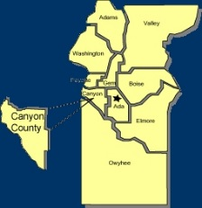
Canyon County Utility Coordinating Council
c/o 50 S Cole Rd.,
Boise, ID 83709
Canyon County UCC Meeting Notes – Wednesday 3-21-2018

- Brian opened at 11:58am

- Cash in Bank: $ 1,603.26

- Minutes motioned to be accepted and seconded

Old business

Approved March minutes
Volunteers for representing CCUCC for state UCC at IGC conference room

New Business

Group discussion about clearance regulations under water ways.

Agency Reports:

Idaho Power :

  - See attachment

Intermountain Gas :
  - 12” on Ustick completed in 3-4 weeks then across interstate in late April, then trenching in June
  - Hwy 44 and Stoffel, placing a bigger reg station for Stoffel to Hwy 16
  - Valve maintenance season has started

Digline
  - 700+ over last year, 500 over 2016
  - Still hiring
  - No more faxes accepted by the end of the month
  - Still looking around July 1st for “due date” change to go into effect

Das-Co :
  - Alley replace off Midland
  - Ustick bore across RR
  - Flamingo trailer park gas line replacement

Williams :
  - Still calm
  - 5000-6000’ of pipe to be replaced in Ada county, new valves being placed

ELM :
  - Hiring and training. Very busy.

Nampa Highway District :
  - Track road, Stagecoach to Kuna
  - Burke Ln bridge almost done
  - Victory and Robinson roundabout approved and going to bid

ITD :
  - I-plan handout

adjourned at 12: 30pm

